Integration Test Case

**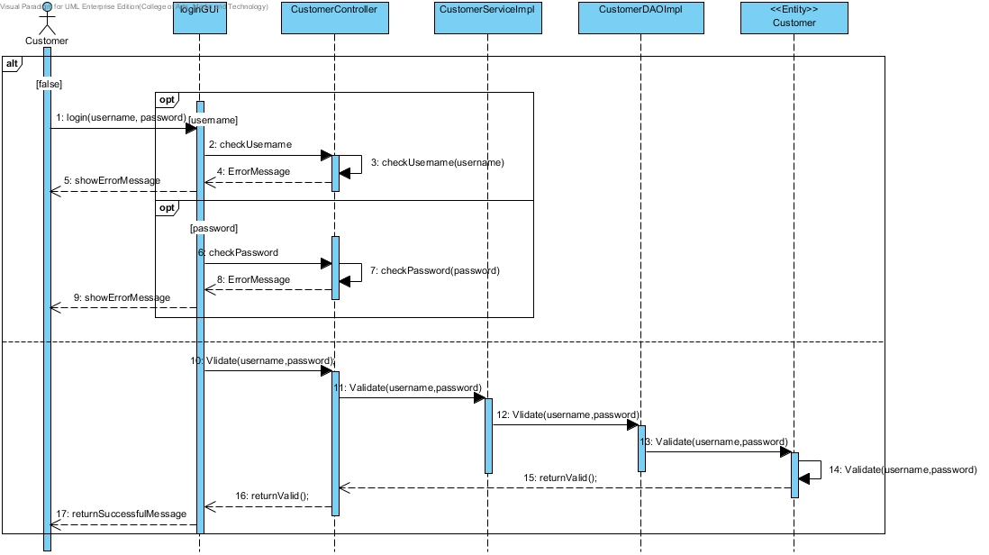**URS-01 : The customer can login to the system by using username and password.

**SD-01** : Customer Login

**ITC-01**

**Description:** Check the integration between CustomerService and CustomerDAO by validateUsername() method

**Table: User**

|  |  |
| --- | --- |
| Name | “Kanokwan Maneerat” |
| Address | “Chiang Mai” |
| Username | “Gloyjai123” |
| Password | “Bt999” |
| Image | vcm_s_kf_m160_155x160.jpg  Me.jpg |
| Role | 2 |

**Test case:**

|  |  |  |
| --- | --- | --- |
| **Test Case ID** | UAT\_TC 01 | |
| **Test Item(s)** | CustomerService → CustomerDAO | |
| **Test Description** | Validate customer account from username that user input | |
| **Input** | **Username:** | Gloyjai123 |
| **Password:** | Bt999 |
| **Expect Output** | Return true if username is match with database format. | |

URS-02: The administrator can login to the system by using username and password.

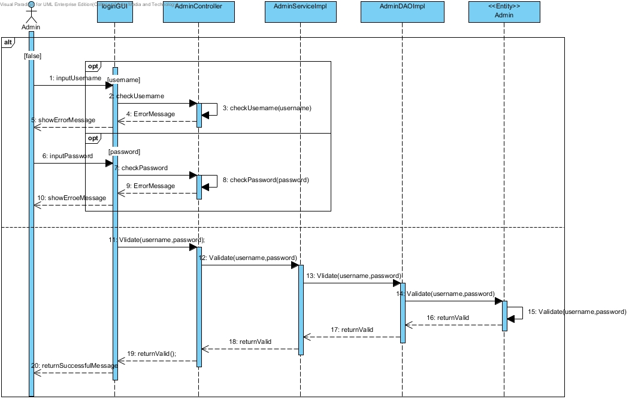

**SD-08**: Admin login

**ITC-02**

**Description:** Check the integration between AdminService and AdminDAO by validateAdminname() method

**Table: Admin**

|  |  |
| --- | --- |
| **Username** | admin |
| **Password** | 1234 |
| **Role** | 1 |

**Test case:**

|  |  |  |
| --- | --- | --- |
| **Test Case ID** | UAT\_TC 02 | |
| **Test Item(s)** | AdminService → AdminDAO | |
| **Test Description** | Validate admin account from adminname that admin input | |
| **Input** | **Adminname:** | admin |
| **Password:** | 1234 |
| **Expect Output** | Return true if username is match with database format. | |

URS-03 : The customer can register to the system by provide the name, address, picture, username, and password.

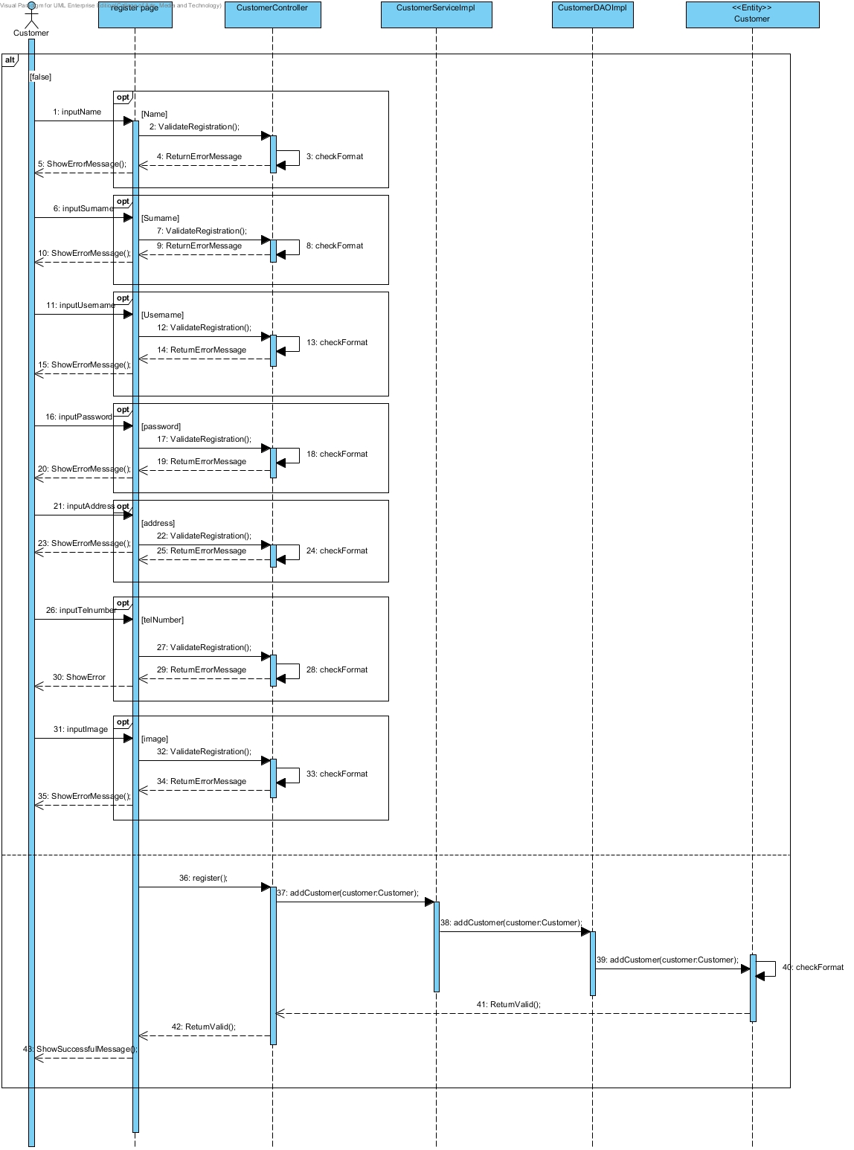

**SD-02:**Customer register

**ITC-03**

**Description:** Check the integration between CustomerService and CustomerDAO by addUser() method

**Table: User**

|  |  |
| --- | --- |
| Name | “Kanokwan Maneerat” |
| Address | “Chiang Mai” |
| Username | “Gloyjai123” |
| Password | “Bt999” |
| Image | vcm_s_kf_m160_155x160.jpg  Me.jpg |
| Role | 2 |

**Test case:**

|  |  |  |
| --- | --- | --- |
| **Test Case ID** | UAT\_TC 03 | |
| **Test Item(s)** | CustomerService → CustomerDAO | |
| **Test Description** | Customer register to the system | |
| **Input** | **Name:** | Kanokwan Maneerat |
| **Address:** | Chiang Mai |
| **Username:** | Gloyjai123 |
| **Password:** | Bt999 |
| **Image:** | vcm_s_kf_m160_155x160.jpg  Me.jpg |
| **Expect Output** | Return to index page and customer can login to the website. | |

URS-04: The customer can update their information.

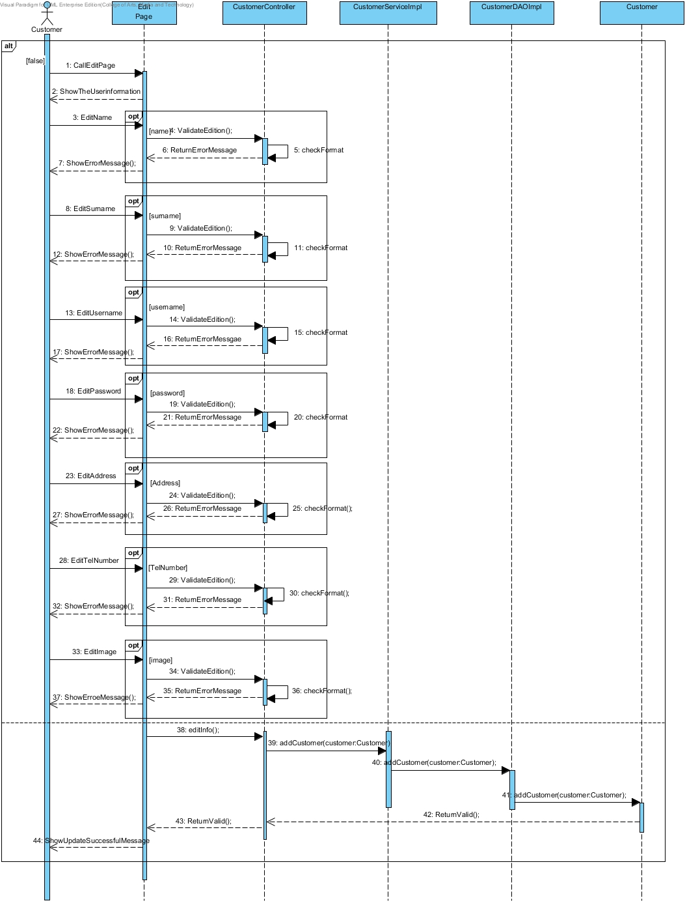

**SD-03:** customer update information

**ITC-04**

**Description:** Check the integration between CustomerService and CustomerDAO by validateUsername() method

**Table: User**

|  |  |
| --- | --- |
| Name | “Kanokwan Maneerat” |
| Address | “Chiang Mai” |
| Username | “Gloyjai123” |
| Password | “Bt999” |
| Image | vcm_s_kf_m160_155x160.jpg  Me.jpg |
| Role | 2 |

**Test case:**

|  |  |  |
| --- | --- | --- |
| **Test Case ID** | UAT\_TC 04 | |
| **Test Item(s)** | CustomerService → CustomerDAO | |
| **Test Description** | Customer register to the system | |
| **Input** | **Name:** | Kanokwan Maneerat |
| **Address:** | Bankok |
| **Password:** | Bt999 |
| **Image:** | vcm_s_kf_m160_155x160.jpg  Me.jpg |
| **Expect Output** | Return to index page and customer can login to the website. | |

URS-05: The customer can log out from the system.

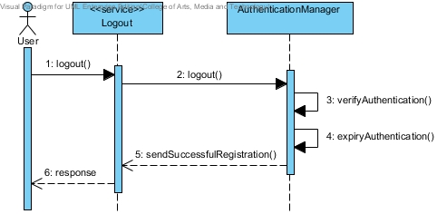

**SD-13**: logout

**ITC-05**

**Description:** Check the integration between CustomerService and CustomerDAO by getLoginPage() method

**Table:** none

**Test case:**

|  |  |
| --- | --- |
| **Test Case ID** | UAT\_TC 05 |
| **Test Item(s)** | CustomerService → CustomerDAO |
| **Test Description** | Customer logout from the system |
| **Input** | none |
| **Expect Output** | Return to index page. |

URS-06: The administrator can add product and provide details of the product which contain product name, product description, and picture of product.

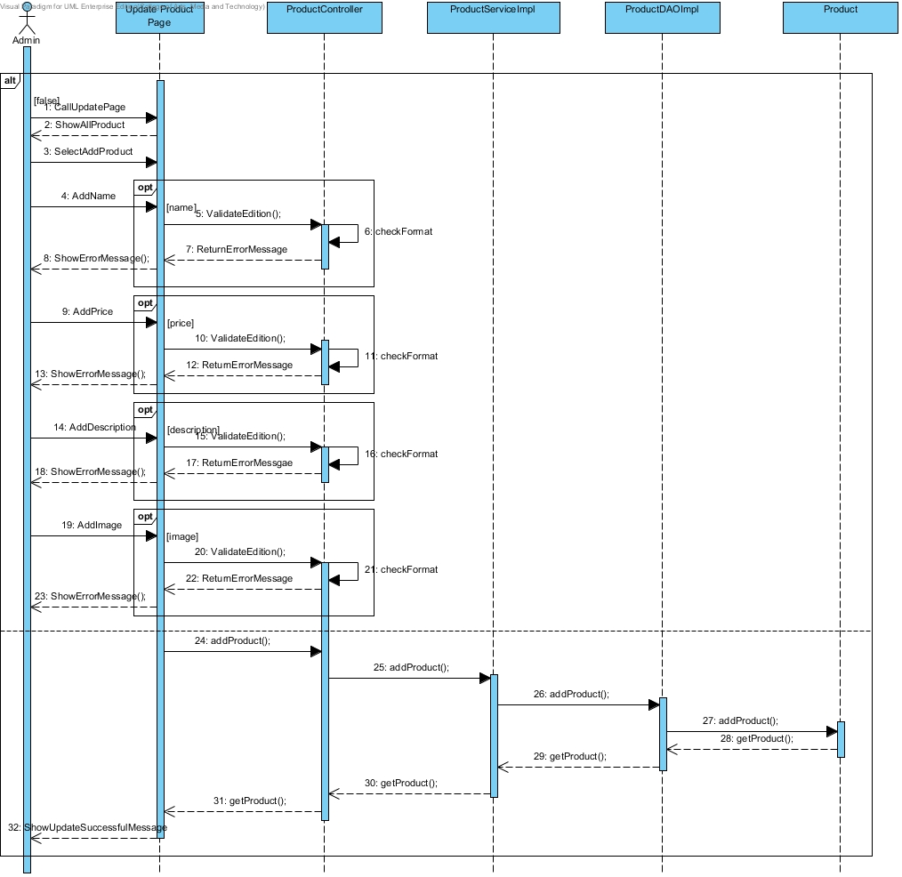

**SD-11** : Add product by admin

**ITC-06**

**Description:** Check the integration between ProductService and ProductDAO by addProduct() method

**Table:** Product

|  |  |
| --- | --- |
| PID | 1 |
| Product Name | Brownie |
| Product Description | A brownie is a chocolate flat. |
| Price | 29.00 |
| Image | Aglayan pasta.jpg  Brownie.jpg |

**Test case:**

|  |  |  |
| --- | --- | --- |
| **Test Case ID** | UAT\_TC 06 | |
| **Test Item(s)** | ProductService → ProductDAO | |
| **Test Description** | Customer logout from the system | |
| **Input** | **Product Name:** | Brownie |
| **Product Description:** | A brownie is a chocolate flat. |
| **Price:** | 29.00 |
| **Image:** | Aglayan pasta.jpg  Brownie.jpg |
| **Expect Output** | Return to index page. | |

URS-07: The administrator can see the shopping history of all customers in his/her page.

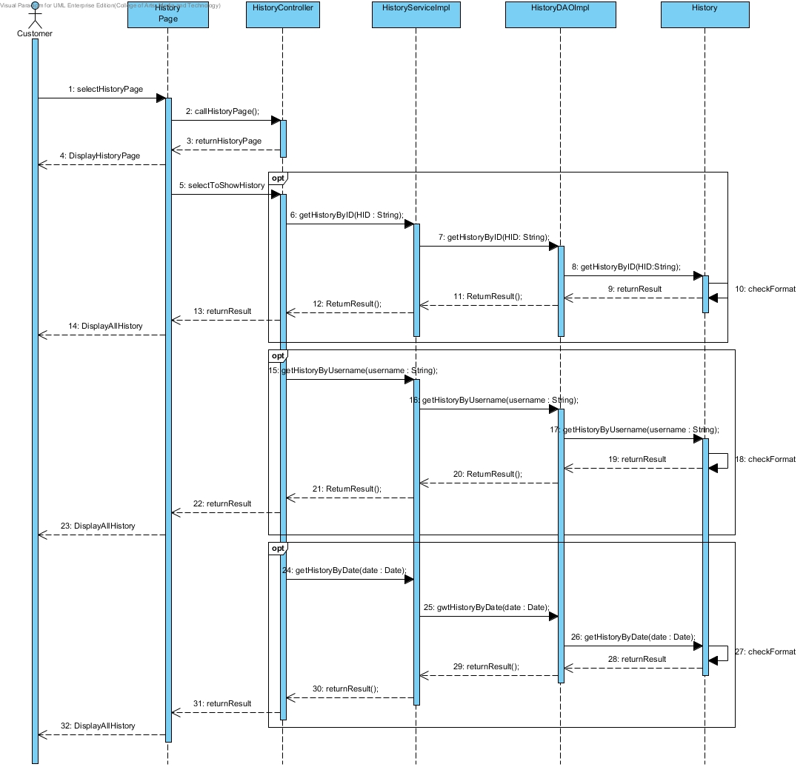

**SD-09:** View history by admin

**ITC-07**

**Description:** Check the integration between HistoryService and HistoryDAO by list() method

**Table:** none

**Test case:**

|  |  |
| --- | --- |
| **Test Case ID** | UAT\_TC 07 |
| **Test Item(s)** | HistoryService → HistoryDAO |
| **Test Description** | View history of all customer by admin |
| **Input** | none |
| **Expect Output** | Show history page. |

URS-08 : The customer can browse the catalog.

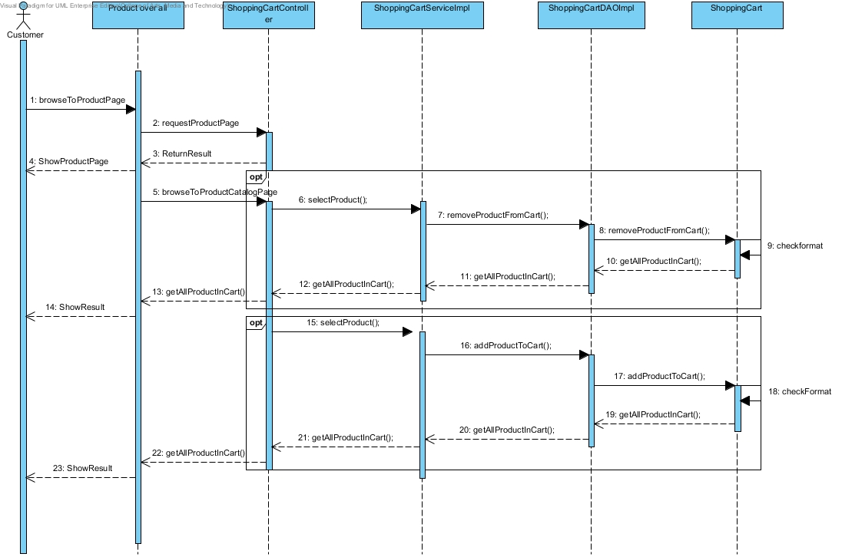

**SD-06:** Select product to shopping cart

**ITC-08**

**Description:** Check the integration between ProductService and ProductDAO by addProduct() method

**Table:** Product

|  |  |  |
| --- | --- | --- |
| PID | 1 | 2 |
| Product Name | Brownie | Browno |
| Product Description | A brownie is a chocolate flat. | A browno of bobo |
| Price | 29.00 | 30.50 |
| Image | Aglayan pasta.jpg  Brownie.jpg | C:\Users\SONY\Desktop\Cakeshop\web\images\b5.jpgBrowno.jpg |

**Test case:**

|  |  |
| --- | --- |
| **Test Case ID** | UAT\_TC 08 |
| **Test Item(s)** | ProductService → ProductDAO |
| **Test Description** | Customer brows to catalog. |
| **Input** | Click cake to view product list. |
| **Expect Output** | Show product list page. |

URS-10 : The customer can choose the product to shopping cart as many products as he/she wants.



**SD-06**: Select product to shopping cart

**ITC-09**

**Description:** Check the integration between ShoppingCartService and ShoppingCartDAO by addProduct() method

**Table:** Shoppingcart

|  |  |
| --- | --- |
| CartID | 1 |
| Username | Gloyjai123 |
| PID | 1 |

**Test case:**

|  |  |
| --- | --- |
| **Test Case ID** | UAT\_TC 09 |
| **Test Item(s)** | ShoppingCartService → ShoppingCartDAO |
| **Test Description** | Customer add product to shopping cart |
| **Input** | Click add product to add product to shopping cart. |
| **Expect Output** | Show shopping cart page. |

URS-11: The customer can see the summary of his/her shopping cart.

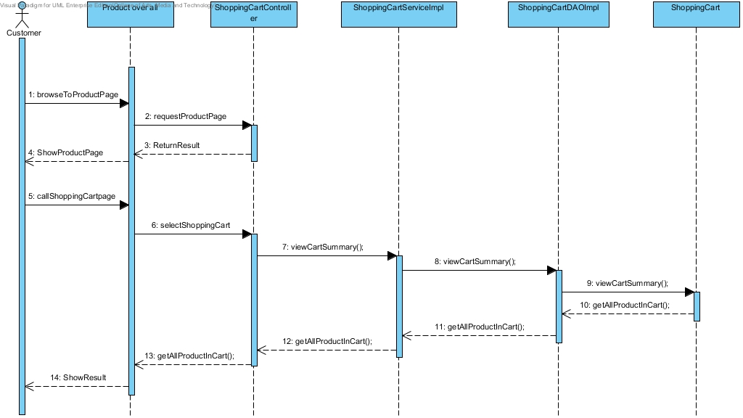

**SD-14:** summary of the customer’s shopping cart.

**ITC-10**

**Description:** Check the integration between ShoppingCartService and ShoppingCartDAO by addProduct() method

**Table:** Shoppingcart

|  |  |
| --- | --- |
| CartID | 1 |
| Username | Gloyjai123 |
| PID | 1 |

**Test case:**

|  |  |
| --- | --- |
| **Test Case ID** | UAT\_TC 10 |
| **Test Item(s)** | ShoppingCartService → ShoppingCartDAO |
| **Test Description** | Customer view summary of shopping cart. |
| **Input** | Click at shopping cart button to view summary of current shopping cart |
| **Expect Output** | Show shopping cart page. |